**Values-Based Banking**

*Course Syllabus*

Version: 2.0

Date: 26/07/2023

**Introduction into Conscious Business Education**

Our purpose is to educate the current and next generation of business leaders and entrepreneurs in Europe to conduct business consciously.​ *Consciously* refers to conducting business in a way that is purpose-driven, ethical, human-centered, sustainable, and inclusive, and where all Business Stakeholders (not only shareholders and managers) benefit. For the last 10-15 years, researchers are increasingly demonstrating that consciously led companies create benefits for all stakeholders while prospering financially above and beyond shareholder-driven companies in many cases. Consciously led companies break through the false choice of *either* you are financially successful, *or* you do good. Conscious businesses have shown to be financially highly successful *and* generate benefits for all stakeholders at the same time. ​However, the practices of conscious business – and what might be different from a traditional view of business – is not yet an explicit part of business education in Europe.

The current economic system is under rising pressure because of unsustainable exploitation of resources and increasing pollution of our planet. Climate change, resource exhaustion, societal inequalities in wealth and access to opportunities are rising. These problems are not separate crises – they can all be rooted in fundamental flaws of the current economic system. A conscious business approach implies a fundamental change towards an economy that is sustainable, circular, prosperous, and inclusive.

Many of the challenges Europe faces require businesses, or support from businesses to create innovative solutions​. Businesses are the dominant drivers for innovation, jobs, and economic wealth, which in turn address real problems of real people. Conscious businesses can do this while making healthy profits and without causing ‘collateral’ damage to nature, employees, health, equality, or local communities.​ Currently, too many businesses are still operating in the old paradigm of material gain while depleting resources, making them (major) contributors to some of our biggest problems such as climate change, inequality, public health, and loss of biodiversity.

We believe businesses can be drivers of good, if they design, organize, and create their business consciously. Therefore, it is of paramount importance to educate current and future business leaders regarding how to manage more consciously so that potential damage is eliminated or minimized, and to increase benefits to society and the planet. We aim to address this challenge by creating and teaching an innovative business syllabus which includes Conscious Business Practices for bachelor-, master- and executive-level education.​ Based upon the Syllabus, Conscious Business Education trains current business teachers how to incorporate the Syllabus into their business education courses and/or programs.​

Goals for the complete syllabus on Conscious Business (21 courses):

1. Describe and teach innovative methodologies to help business students become more conscious leaders.
2. Understand tools and methodologies for conscious business.
3. Apply tools and methodologies to manage businesses better.
4. Embed ethics and ethical dilemmas in every course.
5. Stimulate reflection and development of leaders to become more system-oriented, ethical, inclusive, and conscious.
6. Highlight the superiority of purpose-driven companies.

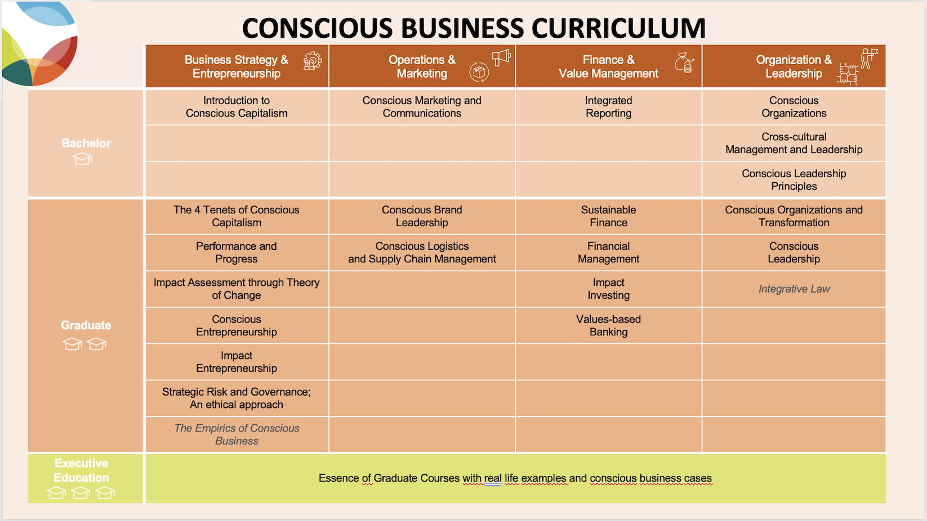



**Overview**

|  |  |
| --- | --- |
| **Course Code** | TBD |
| **Course Title** | Value-based Banking |
| **Degree** | MBA; MA; MSC. This can be a complementary course for any graduate course (to understand the new tendencies in impact oriented and value-based banking. |
| **Teaching and Learning Methods** | * **Course Material document:** Full course material reading with bibliography. Self-study * **Power point presentation:** Summarized course material for professor to lead classes and interact with students. * **Notes:** Support/complementary info/ideas for slide’s topic (when apply) * **Video Cases:** Go to note videos in ppt. * **Business Cases.** As detailed below in this Syllabus. * **Interactive activities:** Go to notes 4 and 9 in ppt |
| **Special Features** | Though there is a Teaching notes document. Most of the detailed teaching notes are in the “notes” of the PPT file.  Since there is a detailed content document that goes through every detail of the course and most of the theoretical framework, teachers must read and explore the content document before adapting the course to their needs. |
|  |  |
| **Expectations towards the students** | Students should be genuinely interested in the role of finance in society as a potential force for good. They would also have to be ready to engage in continuous and challenging dialogues and conversations on the topics associated with the course. |
| **Prerequisites** | Previous knowledge of banking and finance is a nice-to-have, although the course is conceptual enough to be taken by graduate students that come from a diferent background. |
|  |  |
| **Course Length** | 45 academic hours |
| **Number of ECTS Credits** | 1,5 ECTS |
| **Total workload** | 15 hours on-site  30 hours of private study  45 hours of total workload |
| **Assessment** | Suggested weighting of assignments and Banks to be analyzed, to be adjusted by course instructor:   1. Individual assignment (40% of grade). Research one of the Banks belonging to the GABV. Respond to fundamental qüestions as posed by the instructor and find evidences, facts and figures that support the alignment of the bank with the principles of Value-based Banking. 2. Team assignments (60% of grade). In teams, students fo deeper into the comparison between the UNEP-FI PRB and the GABV PVBB and perform a 15-20 minute presentation comparing both and giving specific examples of Banks under any of the frameworks to support their statements. |
|  |  |
| **Course creator from Conscious Business Education** | Creator: Dr. Marcos Eguiguren Huerta, [marcos.eguiguren@bsm.upf.edu](mailto:marcos.eguiguren@bsm.upf.edu)  Affiliation: UPF-Barcelona School of Management  Academic peer: Rodrigo Marques Tavares, NOVA, SBE, Lisbon [rodrigo.tavares@novasbe.pt](mailto:rodrigo.tavares@novasbe.pt)  External peer: Tom Cummings, GABV, Club of Rome, BLab Europe, [tom@now.partners](mailto:tom@now.partners) |
| **Course Material Language** | English |

**Introduction to the course**

The course goes from the history and role of banking in society to the modern concept of ethical or Values-based banking.

By going through the principles of Values-based banking, it visits examples and business cases that clarifies how values-based banks operate and why they are fully impact oriented, even if compared to the most advanced mainstream financial institutions. It is an example of why, by banking in a Values-based way, finance can become a force for good.

The comparison between the principles of value-based banking and the UNEP-FI principles for responsible banking, allow us to clarify the difference between pioneer banks, already banking sustainably and banks that are in the transition.

**Learning objectives**

1. Understand the basics of banking,
2. Understanding which changes should we foster in banks to have them become fully responsible and value-based
3. Go deeper into the principles of Values-based banking, and see the principles in action.
4. Learn which are the differential traits of Values-based banking compared to mainstream banks,
5. Understand why Values-based banks are a transformational force,
6. Compare Values-based banks with other international standards in the field of sustainable finance,

**Course Content**

**Module 1. Introduction and history**

The module provides a very basic understanding of banking as a financial intermediary and some rationales on why banking can become a potential transformational activity. The module also revisits the history of modern banking since the XVIII century till the present times.

**Module 2. The Modern Concept of Value-based Banking**

The course goes into its essence by describing what we can describe as Value-based Banking and by visiting and understanding the purpose and history of the Global Alliance for Banking on Values, the worldwide association that gathers Value-based banks from all over the world.

The module moves into a high-level view of the principles of value-based banking, with a special emphasize on concepts such as purpose, intentionality and consciousness.

**Module 3. Principles One and Two: Triple Bottom Line and Real Economy**

The first two principles of values-based banking are analyzed in depth and are subject to an interconnected interpretation of both while students will review and discuss examples of banks and the way they practice principles one and two, both in the developing world and also in highly developed countries.

**Module 4. Principles Three and Four: Long Term Relationship with Clients and Long-Term Self Sustaining and Resiliency**

Principles three and four of values-based banking are analyzed in depth and are subject to an interconnected interpretation of both while students will review and discuss examples of banks and the way they practice those principles, both in the developing world and also in highly developed countries. Some facts and figures will be shown and discussed.

**Module 5. Principles Five and Six: Transparent and Inclusive Governance and All of These Principles Embedded in the Culture of the Financial Institution**

Principles five and six of values-based banking are analyzed in depth and are subject to an interconnected interpretation of both while students will review and discuss examples of banks and the way they practice both principles. Some case studies will be discussed.

**Module 6. The Principles of Value-Based Banking Compared with UNEP Fi Principles for Responsible Banking**

The module goes into a different framework, the Principles for Responsible Banking, launched by UNEP-FI, and compares it to the principles of Value-based Banking so that students can see the differences and complementarity of both frameworks. Purpose-driven banking models compared to mainstream banks in transition to a different paradigm.

**Module 7. Conclusions**

This final special module invites the students to build together a full set of conclusions after having gone through the whole course. The intention is to co-create a common understanding of how value-based banks can support conscious business and / or how to foster the banking industry to also become a force for change.

**Basic recommended Reading, Video and other Resources**

* *Essence of banking, Kaltrina Shkodra, European Journal of Economics, Law and Social Sciences IIPCCL Publishing, Graz-Austria, Vol 4, No.2, June 2020.* [*https://iipccl.org/wp-content/uploads/2020/06/234-243.pdf*](https://iipccl.org/wp-content/uploads/2020/06/234-243.pdf)
* *Six elements of the financial System*, [*https://ebrary.net/16/business_finance/six_elements_the_financial_system#140*](https://ebrary.net/16/business_finance/six_elements_the_financial_system#140)
* *Role of Banks in econòmic development,* [*https://www.iedunote.com/role-of-banks-in-economic-development*](https://www.iedunote.com/role-of-banks-in-economic-development)
* *Back to Basics: Banks also play a central markets within which they operate,* [*https://www.imf.org/en/Publications/fandd/issues/Series/Back-to-Basics/Banks#:~:text=Banks%20also%20play%20a%20central,markets%20within%20which%20they%20operate*](https://www.imf.org/en/Publications/fandd/issues/Series/Back-to-Basics/Banks#:~:text=Banks%20also%20play%20a%20central,markets%20within%20which%20they%20operate).
* *Cooperative financial institutions: A review of the literature,* [*Donal McKillop*](https://pubmed.ncbi.nlm.nih.gov/?term=McKillop%20D%5BAuthor%5D)*,*[*Declan French*](https://pubmed.ncbi.nlm.nih.gov/?term=French%20D%5BAuthor%5D)*,*[*Barry Quinn*](https://pubmed.ncbi.nlm.nih.gov/?term=Quinn%20B%5BAuthor%5D)*,*[*Anna L. Sobiech*](https://pubmed.ncbi.nlm.nih.gov/?term=Sobiech%20AL%5BAuthor%5D)*, and*[*John O.S. Wilson*](https://pubmed.ncbi.nlm.nih.gov/?term=Wilson%20JO%5BAuthor%5D)*.* [*https://www.ncbi.nlm.nih.gov/pmc/articles/PMC7233224/*](https://www.ncbi.nlm.nih.gov/pmc/articles/PMC7233224/)
* *Social Banking and Social Finance, Roland Benedikter.* [*https://www.researchgate.net/publication/248388817_Social_Banking_and_Social_Finance*](https://www.researchgate.net/publication/248388817_Social_Banking_and_Social_Finance)
* *Values Based Banking: Bringing the Voice of the Citizen into Finance, UNEP Inquiry working paper.*[*https://wedocs.unep.org/bitstream/handle/20.500.11822/9673/-Values_Based_Banking_Bringing_the_Voice_of_the_Citizen_into_Finance-2015Values_Based_Banking_-_Bringing_the_Voice_of_the_Citizen_into_Finance.pdf.pdf?sequence=3&amp%3BisAllowed*](https://wedocs.unep.org/bitstream/handle/20.500.11822/9673/-Values_Based_Banking_Bringing_the_Voice_of_the_Citizen_into_Finance-2015Values_Based_Banking_-_Bringing_the_Voice_of_the_Citizen_into_Finance.pdf.pdf?sequence=3&amp%3BisAllowed)*=*
* [*https://www.gabv.org/*](https://www.gabv.org/)
* *Values-based banks lend 30% more of their total assets than the world’s biggest banks,* [*https://www.gabv.org/press-release/in-the-last-10-years-values-based-banks-lent-30-more-of-their-total-assets-to-the-real-economy-than-the-worlds-biggest-banks/*](https://www.gabv.org/press-release/in-the-last-10-years-values-based-banks-lent-30-more-of-their-total-assets-to-the-real-economy-than-the-worlds-biggest-banks/)
* *Opinion: Facing Covid-19 through the real economy, Adriana Kocornik-Mina,* [*https://www.gabv.org/opinion/facing-covid-19-through-the-real-economy/*](https://www.gabv.org/opinion/facing-covid-19-through-the-real-economy/)
* *What Does Economy Mean? The Difference of Real vs. Financial Economics, Simeon Chapin,* [*https://www.vsecu.com/blog/what-does-economy-mean-the-difference-of-real-vs-financial-economics/*](https://www.vsecu.com/blog/what-does-economy-mean-the-difference-of-real-vs-financial-economics/)
* GABV 2021 Real Economy-Real Returns: The Business Case of Values-based Banking. [*https://www.gabv.org/resources-research/real-economy-real-returns-2021/*](https://www.gabv.org/resources-research/real-economy-real-returns-2021/)
* *Alliance for sustainable futures, Jaap Boostra & Marcos Eguiguren, Edgar Ewar Publishing, London, 2023*

**Other Recommended Readings and Complementary Material**

* [*https://www.investopedia.com/articles/07/banking.asp*](https://www.investopedia.com/articles/07/banking.asp)
* [*https://thefinancialcrimenews.com/a-short-history-of-banking-by-fcn/*](https://thefinancialcrimenews.com/a-short-history-of-banking-by-fcn/)
* [*https://www.technofunc.com/index.php/domain-knowledge/banking-domain/item/history-of-banking*](https://www.technofunc.com/index.php/domain-knowledge/banking-domain/item/history-of-banking)
* *Leadership and organizational culture based on sustainable innovational values: Portraying the case of the Global Alliance for Banking Based on Values (GABV):* [*http://ow.ly/42ep50kmEjY*](http://ow.ly/42ep50kmEjY)
* *Change-makers: The global alliance for banking on values:* [*https://journals.sagepub.com/doi/abs/10.1177/1468018114539864b?journalCode=gspa*](https://journals.sagepub.com/doi/abs/10.1177/1468018114539864b?journalCode=gspa)
* *SDB bank focuses on the real economy to face the crisis in Sri Lanka*,[*https://www.gabv.org/interview/sanasa-development-bank-focuses-on-the-real-economy/*](https://www.gabv.org/interview/sanasa-development-bank-focuses-on-the-real-economy/) *)*
* *VSECU’s energy savings provide individuals with basics needed to live better lives,* [*https://www.gabv.org/stories-from-gabv/vsecus-energy-savings-provide-individuals-with-basics-needed-to-live-better-lives/*](https://www.gabv.org/stories-from-gabv/vsecus-energy-savings-provide-individuals-with-basics-needed-to-live-better-lives/) *)*
* *Client-centered: Uganda’s Centenary bank case,* [*https://www.gabv.org/values-in-practice/intentional-centenary-bank/*](https://www.gabv.org/values-in-practice/intentional-centenary-bank/)
* *Caja Arequipa,* [*https://www.gabv.org/values-in-practice/authentic-caja-arequipa/*](https://www.gabv.org/values-in-practice/authentic-caja-arequipa/)
* *Self-sustaining and facing challenges: The Banca Etica case,*[*https://www.gabv.org/values-in-practice/coherent-banca-etica/*](https://www.gabv.org/values-in-practice/coherent-banca-etica/)
* *Transparent: Beneficial State Bank “Move Your Money” divest/invest initiative,*[*https://www.gabv.org/values-in-practice/transparent-beneficial-state-bank/*](https://www.gabv.org/values-in-practice/transparent-beneficial-state-bank/)
* *Inclusive: Visión Banco and its “constructing dreams” program,* <https://www.gabv.org/values-in-practice/inclusive-vision-banco/>

**Recommended cases**

* GLS case, GABV, OSFE. <https://www.gabv.org/resources-research/gls-bank-case-study-2022/>
* Banca Etica case, GABV, OSFE, <https://www.gabv.org/resources-research/banca-etica-case-study-2022/>