**Course: Couscious Financial Management**

Version: 2.0

Date: 26/07/2023

**Introduction into Conscious Business Education**

Our purpose is to educate the current and next generation of business leaders and entrepreneurs in Europe to conduct business consciously.​ *Consciously* refers to conducting business in a way that is purpose-driven, ethical, human-centered, sustainable, and inclusive, and where all Business Stakeholders (not only shareholders and managers) benefit. For the last 10-15 years, researchers are increasingly demonstrating that consciously led companies create benefits for all stakeholders while prospering financially above and beyond shareholder-driven companies in many cases. Consciously led companies break through the false choice of *either* you are financially successful, *or* you do good. Conscious businesses have shown to be financially highly successful *and* generate benefits for all stakeholders at the same time. ​However, the practices of conscious business – and what might be different from a traditional view of business – is not yet an explicit part of business education in Europe.

The current economic system is under rising pressure because of unsustainable exploitation of resources and increasing pollution of our planet. Climate change, resource exhaustion, societal inequalities in wealth and access to opportunities are rising. These problems are not separate crises – they can all be rooted in fundamental flaws of the current economic system. A conscious business approach implies a fundamental change towards an economy that is sustainable, circular, prosperous, and inclusive.

Many of the challenges Europe faces require businesses, or support from businesses to create innovative solutions​. Businesses are the dominant drivers for innovation, jobs, and economic wealth, which in turn address real problems of real people. Conscious businesses can do this while making healthy profits and without causing ‘collateral’ damage to nature, employees, health, equality, or local communities.​ Currently, too many businesses are still operating in the old paradigm of material gain while depleting resources, making them (major) contributors to some of our biggest problems such as climate change, inequality, public health, and loss of biodiversity.

We believe businesses can be drivers of good, if they design, organize, and create their business consciously. Therefore, it is of paramount importance to educate current and future business leaders regarding how to manage more consciously so that potential damage is eliminated or minimized, and to increase benefits to society and the planet. We aim to address this challenge by creating and teaching an innovative business syllabus which includes Conscious Business Practices for bachelor-, master- and executive-level education.​ Based upon the Syllabus, Conscious Business Education trains current business teachers how to incorporate the Syllabus into their business education courses and/or programs.​

Goals for the complete syllabus on Conscious Business (21 courses):

1. Describe and teach innovative methodologies to help business students become more conscious leaders.
2. Understand tools and methodologies for conscious business.
3. Apply tools and methodologies to manage businesses better.
4. Embed ethics and ethical dilemmas in every course.
5. Stimulate reflection and development of leaders to become more system-oriented, ethical, inclusive, and conscious.
6. Highlight the superiority of purpose-driven companies.

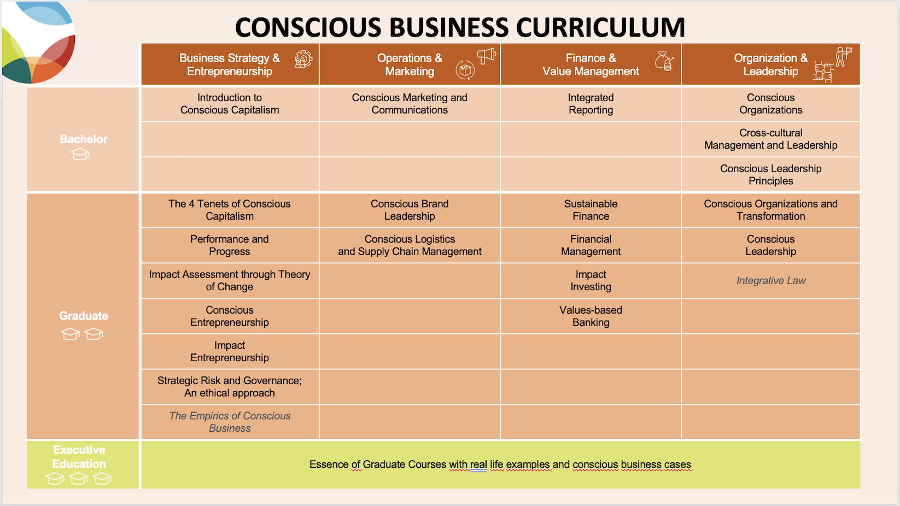

**Overview**

|  |  |
| --- | --- |
| **Course Description** | This course shall discuss conscious financial behaviors, the role of a financial manager in the conscious decision making, and the importance of ethics in the finance profession.  The course also covers the practical application of financial management in understanding the difference between (moderate) earnings management and (extreme) financial fraud, the definitions, the detection techniques, and some guidelines for a conscious financial behavior in the company’s decision making.  The course prescribes methodology and standards that are consistent with clear and honest presentations of results. |
| **Degree** | Choose an item. |
| **Learning Objectives** | The objective of the course is to introduce the student in the ethical dimension of the finance profession. In particular, by the end of the course the student is expected to be able to:  - Identify challenges to principled behavior. Be able to distinguish between the admissible management of earnings from financial fraud  - Identify the main tools to detect financial fraud.  - Understand the need for high ethical standards and a good governance in the finance profession.  - Describe and apply a framework for conscious and rightful decision making. |
| **Teaching and Learning Methods** | * The course will combine lectures with case discussions, and presentation of reports about cases made by groups of students. Students might also be discussing conflicting dilemmas in the financial industry. |
| **Special Features** | Click or tap here to enter text. |
| **Literature** | Mandatory readings:   * Standards of Practice Handbook, CFA Institute 2014. * Stiglitz, J. (2019): Project Sindicate. Is Stakeholder Capitalism Really Back?, New York Times. * Giroux, G. (2004). Detecting Earnings Management, Wiley. * Zabihollah Rezaee, Z. and Riley, R (2010). Financial Statement Fraud: Prevention and Detection. Wiley   Additional recommended readings:   * Click or tap here to enter text. |
|  |  |
| **Expectations towards the students** | Click or tap here to enter text. |
| **Prerequisites** | Click or tap here to enter text. |
|  |  |
| **Course Length** | 21 academic hours |
| **Number of ECTS Credits** | 2 ECTS |
| **Total workload** | 21 hours on-site  39 hours of private study  60 hours of total workload |
|  |  |
| **Course creator** | Name: Luz Parrondo  Affiliation: UPF Barcelona School of Management |