**Impact Investment**

*Course Syllabus*

**Introduction to Impact Investment**

The focus of this course is to introduce students to the emerging topic of Impact Investment. Students will be able to understand the value proposition of impact investment, how impact is a key economic opportunity being driven by major market forces - consumers, investors and employees - and how it will shape capital allocation and economic decisions.

At the end of the course, students are expected to understand how financial innovation can be applied towards tackling the most pressing social and environmental problems and be aware of the different financing instruments available. This includes learning from live case studies in microfinance, social impact bonds, impact investment funds and other mechanisms.

This course will be led by learnings from the ground and supported by theoretical fundamentals. The debate will be encouraged around social issues such as poverty reduction, community capacity, and international development alongside contemporary topics including youth unemployment, homelessness and education. Students will be provided with quantitative and qualitative information to support these discussions.

All subjects and topics will be presented through live case studies alongside a literature overview in order to help to deepen the understanding of the subject and support the work in class. The course is prepared to embrace a diverse class comprised by students from different academic backgrounds and with or without field experience. Students are not required to have previous financial background.

**Overview**

|  |  |
| --- | --- |
| ***Course Code*** |  |
| ***Course Title*** | Impact Investment |
| ***Degree*** | MA / Graduate |
| ***Course Length*** | 18 hours |
| ***Number of ECTS Credits*** | 2 ECTS |
| ***Total workload*** | 18 hours on-site lectures and instruction  20 hours of private study  32 hours of assignments  60 hours of total workload |
| ***Prerequisites*** | None |
| ***Teaching and Learning Methods*** | Learning by examples (demonstration)  Case studies (class discussion)  Learning by doing (assignments) |
| ***Assessments*** | Class participation: 15%  Group assignment: 40%  Individual assignment: 45% |
| ***Course creators from Conscious Business Education*** | Creator: António Miguel, NOVA SBE, antonio.miguel@novasbe.pt  Academic peer: Marcos Eguiguren, UPF Barcelona School of Managamenet, marcos.eguiguren@gmail.com  External peer: João Machado, AGEAS Foundation |
| ***Course Material Language*** | English |

**Introduction to the Course**

Impact investments are those that intentionally target specific social objectives along with a financial return and measure the achievement of both. The increasing collaboration between the private, public and social sector is fostering the growth of the social innovation and social entrepreneurship sector – this emerging sector is the source of many of the systemic changes, partnerships and innovation in the past decade.

The emergence of new funding mechanisms for social innovation and impact entrepreneurship is at the core of impact investment. Understanding social issues and using finance to solve them is a complex issue that demands rigorous analysis and talented resources. That is the underlying assumption for this class.

**Learning Outcomes / Objectives**

Knowledge and Understanding

- Understand the relevance of financial innovation in tackling entrenched social and environmental problems.

- Reflect on the link between the social sector, financial markets and public policy.

- Understand the impact that innovative financial instruments have in solving specific problems such as youth unemployment, poverty and social exclusion.

- Focus on the root causes of problems and how finance can be used to unlock these obstacles.

- Reflect on new trends in impact investment.

Subject-Specific Skills

- Critically assess impact investment based on theoretical fundamentals and lessons learned so far.

- Be able to analyse the design and impact of impact investment products.

General Skills

- Presentation skills and ability to back arguments with qualitative and quantitative analysis.

- To give and receive constructive feedback.

- To bridge and structure theoretical and practical information around one issue.

**Course Content (incl. Module Description)**

An introduction to Impact Investment:

- Mobilisation of capital for public good and the role of financial innovation in tackling societal issues.

- A convergent economy: the intersection between private, public and social sector.

- A new investment paradigm: risk, return and impact.

- Financial innovation for impact: the spectrum of impact finance instruments.

The impact investment market infrastructure:

- Creating an impact investment market: lessons from the UK, US, Canada and Continental Europe.

- Building institutional infrastructure: live case study of Big Society Capital in the UK.

- Understanding the dynamics of an impact investment market: impact investors, investees and public sector.

- Promoting investment readiness: learnings from impact acceleration programmes.

Financial innovation to deliver social change:

- Microfinance: theoretical fundamentals, impact of microfinance, credit technologies and state of the art in developed and developing economies.

- Social Impact Bonds: shift towards outcomes-based financing, capital allocation for social innovation, learnings from case studies (Peterborough).

- Impact Investment Funds: the role of equity and quasi-equity instruments in building resilient social organisations, learnings from live case studies.

- Venture Philanthropy: focus on long-term financial and non-financial support to build capacity within social organisations, learnings from live case studies (Impetus Private Equity Foundation).

- Impact Finance Innovation: equity crowdfunding, quasi-equity instruments for social organisations (revenue shared agreements).

Broader overview and market trends:

- Impact Finance trends: emerging concepts and new markets.

- Big data and analytics to advance social innovation.

- Role of impact investment in tackling entrenched social problems.

**Expectation toward the students**

At the end of the course, students are expected to understand how financial innovation can be applied towards tackling the most pressing social and environmental problems and be aware of the different financing instruments available. This includes learning from live case studies in microfinance, social impact bonds, impact investment funds and other mechanisms.

**Teaching and Learning Methods used**

We will use different methods that create dynamic classes and enhance the real long-term learning:

- lectures by the teacher and live-voting system to foster discussion.

- in-class presentations by key practitioners in the international impact investment market that will be invited to share their experience.

- group and individual work in and extra-class.

We also use reading exercises, debates, videos watching and discussing, case studies analysis and interactive activities that will deepen the acquired knowledge, allow practical application of the concepts and give them an essential reality check.

**Prerequisites**

None

**Special Features of this Course**

Case studies:

- Peterborough Social Impact Bond

- Impact America Venture Capital Fund

- Compartamos Microfinance

**Course Length**

18 academic hours

**Number of ECTS Credits**

2 ECTS

**Total Workload**

This is a 2 ECTS course. This means a 2 * 30 = 60 hrs. workload for students.

|  |  |  |
| --- | --- | --- |
| Attending sessions | 6 * 3 hrs. | 18 hrs. |
| Private study | Approximately 120 slides + 5 readings | 20 hrs. |
| Assignments | 2 assignments + class participation | 32 hrs. |
| **TOTAL** |  | 60 hrs. |

**Assessments**

Group assignment assessment criteria: Analysis and understanding of the topic; clear articulation of ideas and logic structure of the assignment; capacity to build feasible and relevant recommendations; extra research; ability to back arguments and decisions; formalities.

Individual assignment assessment criteria: Analysis and understanding of the topic; clear articulation of ideas and logic structure of the assignment; critical thinking; extra research; formalities.

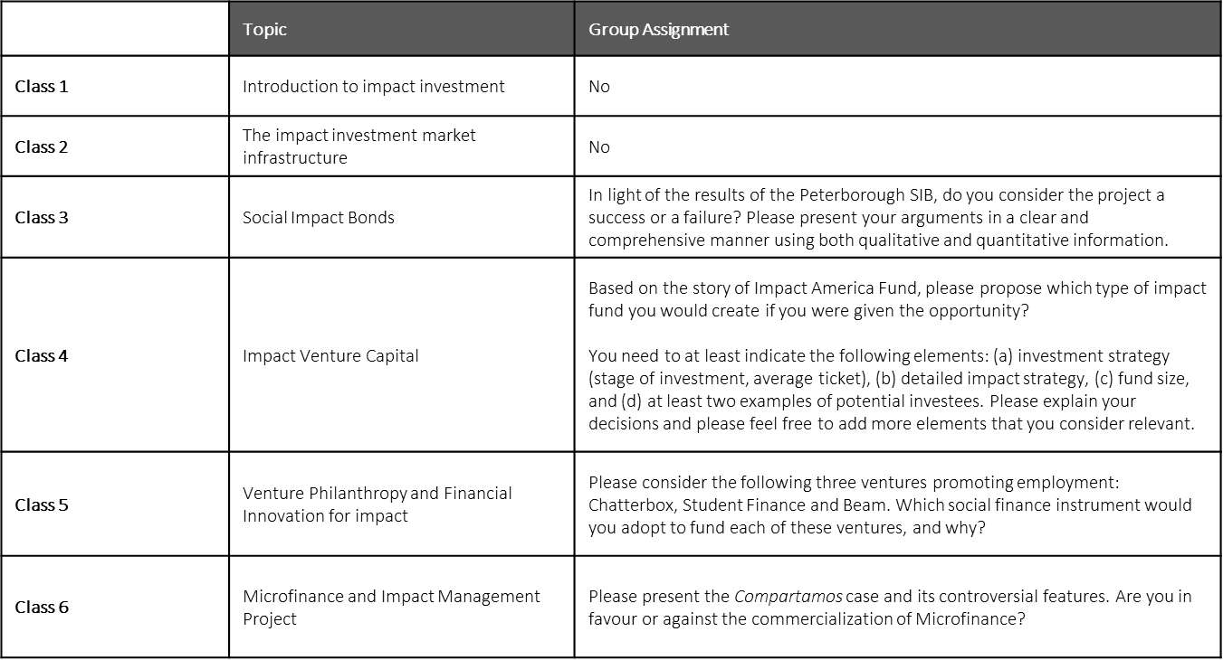

**Suggested Literature**

- The invisible heart of the markets, a report by the Global Social Impact Investment Steering Group, available here <https://gsgii.org/reports/impact-investment-the-invisible-heart-of-markets/>

- Angels in the architecture, Building the infrastructure of social investment, Dan Gregory, available here <https://www.tnlcommunityfund.org.uk/media/insights/documents/Angels-in-the-Architecture-report.pdf?mtime=20210625153931&focal=none>

- A Technical guide to developing social impact bonds, Social Finance, available here <https://www.socialfinance.org.uk/insights/a-technical-guide-to-developing-social-impact-bonds>

- Financing for social impact, the key role of tailored financing and hybrid finance, European Venture Philanthropy Association, available here <https://www.evpa.ngo/insights/financing-social-impact-key-role-tailored-financing-and-hybrid-finance>

**Communication**

Communication is done via e-mail, or any other platform adopted for the purpose of this course.

**Classroom rules**

- Participation in class and engagement in debate are key and will be considered for evaluation purposes. Feel free to ask questions throughout the class.

- When people don’t understand, they tend to nod their heads. There are no stupid questions.

- Class structure: focus on theory + focus on debate.

- Literature review is available for each class.

- When guest speakers come to class, please be adequately prepared to engage in discussion.

- Impact ventures, social enterprises, impact startups: All the same in the context of this class.

**Course creators from *Impact Investment***

Creator: António Miguel, NOVA SBE, antonio.miguel@novasbe.pt

Academic peer: Marcos Eguiguren, UPF Barcelona School of Managamenet, marcos.eguiguren@gmail.com

External peer: João Machado, AGEAS Foundation

**Sources that were used to create this course**

The key sources to produce this course were the following:

- Experience and direct engagement of the creator of this course in impact investment over 15 years, hence bringing first-hand experience to the various case studies discussed (e.g., Social Impact Bonds, Impact Venture Capital, Venture Philanthropy).

- The invisible heart of the markets, a report by the Global Social Impact Investment Steering Group