**Course: Conscious Supply Chain**

Version: 2.0

Date: 26/07/2023

**Introduction into Conscious Business Education**

Our purpose is to educate the current and next generation of business leaders and entrepreneurs in Europe to conduct business consciously.​ *Consciously* refers to conducting business in a way that is purpose-driven, ethical, human-centered, sustainable, and inclusive, and where all Business Stakeholders (not only shareholders and managers) benefit. For the last 10-15 years, researchers are increasingly demonstrating that consciously led companies create benefits for all stakeholders while prospering financially above and beyond shareholder-driven companies in many cases. Consciously led companies break through the false choice of *either* you are financially successful, *or* you do good. Conscious businesses have shown to be financially highly successful *and* generate benefits for all stakeholders at the same time. ​However, the practices of conscious business – and what might be different from a traditional view of business – is not yet an explicit part of business education in Europe.

The current economic system is under rising pressure because of unsustainable exploitation of resources and increasing pollution of our planet. Climate change, resource exhaustion, societal inequalities in wealth and access to opportunities are rising. These problems are not separate crises – they can all be rooted in fundamental flaws of the current economic system. A conscious business approach implies a fundamental change towards an economy that is sustainable, circular, prosperous, and inclusive.

Many of the challenges Europe faces require businesses, or support from businesses to create innovative solutions​. Businesses are the dominant drivers for innovation, jobs, and economic wealth, which in turn address real problems of real people. Conscious businesses can do this while making healthy profits and without causing ‘collateral’ damage to nature, employees, health, equality, or local communities.​ Currently, too many businesses are still operating in the old paradigm of material gain while depleting resources, making them (major) contributors to some of our biggest problems such as climate change, inequality, public health, and loss of biodiversity.

We believe businesses can be drivers of good, if they design, organize, and create their business consciously. Therefore, it is of paramount importance to educate current and future business leaders regarding how to manage more consciously so that potential damage is eliminated or minimized, and to increase benefits to society and the planet. We aim to address this challenge by creating and teaching an innovative business syllabus which includes Conscious Business Practices for bachelor-, master- and executive-level education.​ Based upon the Syllabus, Conscious Business Education trains current business teachers how to incorporate the Syllabus into their business education courses and/or programs.​

Goals for the complete syllabus on Conscious Business (21 courses):

1. Describe and teach innovative methodologies to help business students become more conscious leaders.
2. Understand tools and methodologies for conscious business.
3. Apply tools and methodologies to manage businesses better.
4. Embed ethics and ethical dilemmas in every course.
5. Stimulate reflection and development of leaders to become more system-oriented, ethical, inclusive, and conscious.
6. Highlight the superiority of purpose-driven companies.

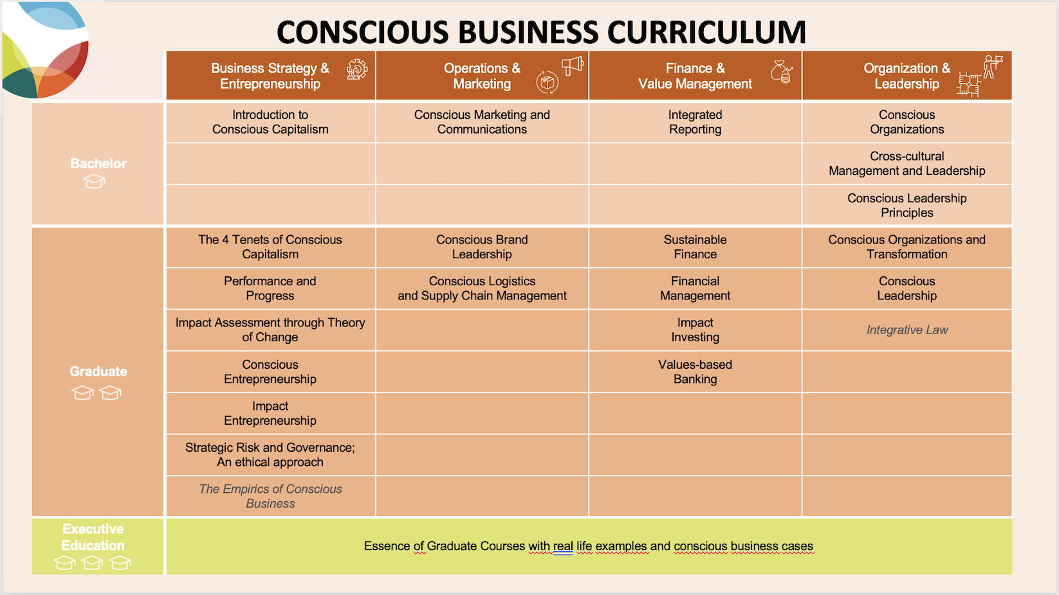

**Overview**

|  |  |
| --- | --- |
| **Course Description** | Conscious Supply Chain is a course that connects sustainability and logistics concepts, it stresses the importance of this relationship, and it offers knowledge that allows executing supply chains that are sustainable at the social, environmental and economic levels.  It is structured in four blocks. First, an introduction to logistics and its historical evolution towards sustainable supply chains. Second, it focuses on customers and processes. Third, the triple transformation is explained, which touches on technology, sustainability and resilience. The final topic is on the leadership in operations. |
| **Degree** | Choose an item. |
| **Learning Objectives** | 1. To understand the historical evolution of supply chains, and gain insight on the latest emerging trends on technology, sustainability and social responsibility, and supply chain resilience.  2. Supply chains are complex systems that involve multiple stakeholders, from suppliers to customers, it is therefore critical to understand the importance of designing operations that balance the needs of all stakeholders involved in the supply chain  3. To learn how to manage processes with a continuous improvement mentality, emphasizing the key issues and challenges supply chains are currently facing, and learning about the tools and techniques needed to address them.  4. To identify the three transformations that affect value chains and to learn strategies to face them: technology, sustainability and resilience.  5. To master two of the main aspects of running operations effectively: organization and objectives. |
| **Teaching and Learning Methods** | To teach this course, a combination of various teaching methods is encouraged to create a dynamic and effective learning environment. First, the use of the PowerPoint presentation provides visual aids and examples that can help students understand complex concepts. However, it should be used in combination with debate questions to prompt critical thinking among students. Students should be encouraged to share personal experiences gained from working in logistics, as this can help others to illustrate key concepts and demonstrate real-world applications of the topics discussed. Professors in this course should also reinforce students to debate opinions, as strong points of view and conflicting perspectives can emerge. Finally, assigned readings supplement the discussions in class and can provide additional insights. |
| **Special Features** | This course can be a steppingstone to further professional development, such as certifications from the European Logistics Association (ELA) or advanced degrees in related fields. |
| **Literature** | Readings:  Mackey, J., Sisodia, R. (2016). Conscious Capitalism. Active Enterprise.  Richards, G., Grinsted, S. (2013). The Logistics and Supply Chain Toolkit. Kogan Page  Carter, C.; Rogers D. (2008). A framework of sustainable supply chain management: Moving toward new theory. International Journal of Physical Distribution & Logistics Management, 38(5), pp. 360-387  Chávez, J.H.,Torres-Rabello, R. (2012). Supply Chain Management. Ril Editores.  Cornfield, G. (2020). The most important metrics you're not tracking (yet). Harvard Business Review  Dobelli, R. (2013). The art of thinking clearly. Hodder & Stoughton  Jullien, F. (2005). Conférence sur l'efficacité. Presses Universitaires de France.  Rouquet, A., (2018). L'invention de la logistique par Antoine-Henri de Jomini. Annales des Mines - Gérer et comprendre, 133(3), pp. 53-61  Servera-Francés, D. (2010). Concept and evolution of the logistics function. Innovar Journal 20 (38), pp. 217-234.  Click or tap here to enter text. |
|  |  |
| **Expectations towards the students** | Class attendance and active participation |
| **Prerequisites** | Click or tap here to enter text. |
|  |  |
| **Course Length** | 18 academic hours |
| **Number of ECTS Credits** | 1,5 ECTS |
| **Total workload** | 18 hours on-site  27 hours of private study  45 hours of total workload |
|  |  |
| **Course creator** | Name: Oriol Montanyà  Affiliation: UPF Barcelona School of Management |